USER INTERFACE DESIGN DOCUMENT  
for

FAULT TOLERANT SHIP-BOARD DATA LOGGING AND PROCESSING SYSTEM

**Customer**: Nils Haëntjens  
 School of Marine Science  
  
**Prepared by**: **Team Aqua:**  
 Jacob Hall  
 Sam Segee  
 Chi Anh Nguyen

**Guided by**: Prof. Terry S. Yoo  
  
  
  
  
  
  
  
  
 Fall 2018, COS 397  
 November 30, 2018



**USER INTERFACE DESIGN DOCUMENT**

#### Table of Contents

Page

## 1. Introduction 3

* 1. Purpose of This Document 3
  2. References 3

2. User Interface Standards 4

3. User Interface Walkthrough 6

3.1 Data Visualization User Interface Walkthrough 7

3.2 Data Collection User Interface Walkthrough 17

4. Data Validation 21

Appendix A **-** Agreement Between Customer and Contractor 22

Appendix B – Peer Review Sign-off 23

Appendix C – Document Contributions 24

Appendix D – Version Control 25

## 1. Introduction

1.1 Purpose of This Document

The purpose of this document is to explain the user interface design. First, it will explain the various standards will be used to maintain consistency in the user interface throughout the system. Then it will guide the user through the interface process by providing a navigation diagram that shows elements of the screens. Next, the user will be guided through a series of system screenshots to gain deeper understanding and expectations of the approximation layout design of the system. Finally, it will provide the description of all data items that can be entered into the system by the user, including their type, format(s) and any limitations.

* 1. References

“The University of Maine In-Situ Sound & Color Lab.” *The University of Maine In-Situ Sound & Color Lab*, 18 Mar. 2014, [misclab.umeoce.maine.edu/](http://misclab.umeoce.maine.edu/).

The official website for the MISC Lab located at the University of Maine.

Sommerville, Ian. *Software Engineering*. Pearson Education South Asia Pte Ltd, 2016.

Many aspect of this document are taken from this document. This is document also talk about general software engineering processes.

Segee, Hall, Nguyen. SYSTEM REQUIREMENTS SPECIFICATION for FAULT TOLERANT SHIP-BOARD DATA LOGGING AND PROCESSING SYSTEM. 2018.

Document developed for the fault tolerant ship-board data logging and processing system. The document gives an overview of the project and states the requirements that the system must meet.

Segee, Hall, Nguyen. SYSTEM DESIGN DOCUMENT for FAULT TOLERANT SHIP-BOARD DATA LOGGING AND PROCESSING SYSTEM. 2018.

Document developed for the fault tolerant ship-board data logging and processing system. The document gives an overview of the project design and how the system will be developed describing the structure of the system and how data is managed.

1. **User Interface Standards**

The user interface is composed of two distinct components:

* *Data Collection User Interface*: The primary computer has a logging application from which all settings to log and configure the application are entered, this user interface is only accessible from the primary computer and cannot be modifier remotely.
* *Data Visualization User Interface*: The secondary computer has a data visualization and processing interface accessible through the network with any web browser.

The Data Visualization User Interface is designed to take advantage of the entire browser window, no white space will be left and scrolling should be limited to very small windows. In addition, the application should also be compatible with smartphone screen.

The web application is composed of three tabs: *Overview*, *Process Data*, and *App Status*. These tabs will be available on the top right of every page of the website, allowing quick access to each (see *Figure 1*).

* *Overview* will allow the user to view data collected from each sensor in a graph as well as check the connectivity and packets received by each sensor.
* *Process Data* will allow the user to perform the final steps to make the data fully usable for scientific analysis. This includes syncing up each sensor due to the difference in delays storing data and cutting out any data made unusable from interference such as bubbles going through a sensor (see *Figure 9*).
* *App Status* is a page to the page for data visualization and backup settings. It contains the the status of the logging and processing applications, informations such as size of the backups, space available on each hard drive, quality of connection between the two computers, if data is currently processed, merged, or exported will be displayed. Here the user can navigate the backup directory, gain information on the address of the secondary computer, and the options to restore the sensors’ configuration and import existing data.

The header of the application, present on all pages is composed of:

* A digital clock and the date
* A visible overall logging indicator (red exclamation mark, Figure 1), it turns on if any active instrument is not logging or receiving data.
* Tabs indicating the current page and to navigate through the application

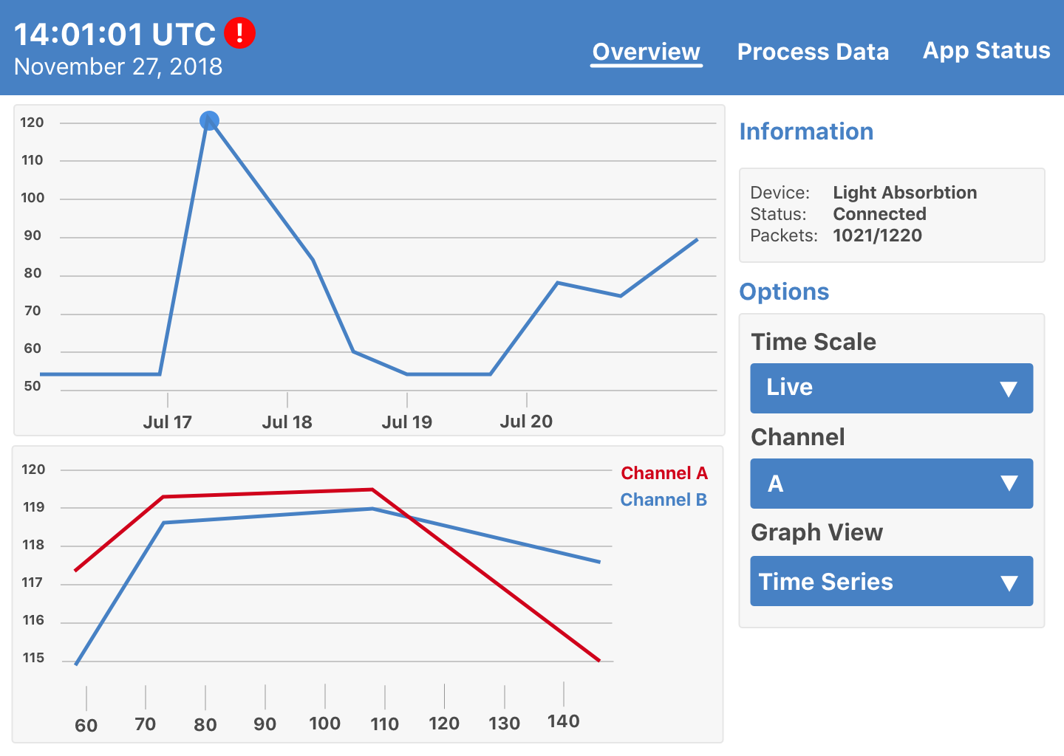

*Figure 1: Viewing a sensor’s status in Overview*

Through the Data Collection User Interface running on the Primary computer, the user can select and adjust instrument type, serial number, and instrument specific parameters such as baud rate, serial port, device file associated with each sensor. Additional settings will be included for sensors that require them, such as the Control Switch that requires specific time inputs (see *Figure 2*). Also, in the settings screen, the user can add or remove instruments with the **+** and **-** signs on the bottom left. On the bottom right (specific to each instrument tab), the user can use the following toggle buttons: *Enable/Disable*, *Connect/Disconnect* or *Start/Stop Data Collection* (see *Figure 2*). The *Enable/Disable* button allows the user to disable the device from any data collecting function, in case the device is not used anymore during the expedition but data is kept for visualization; no warning will be displayed if this instrument is not connected or not logging data. The *Disconnect* button is used to disconnect the device from the system without removing it for future use. The *Start/Stop Data Collection* will start or stop logging data from a specific instrument.

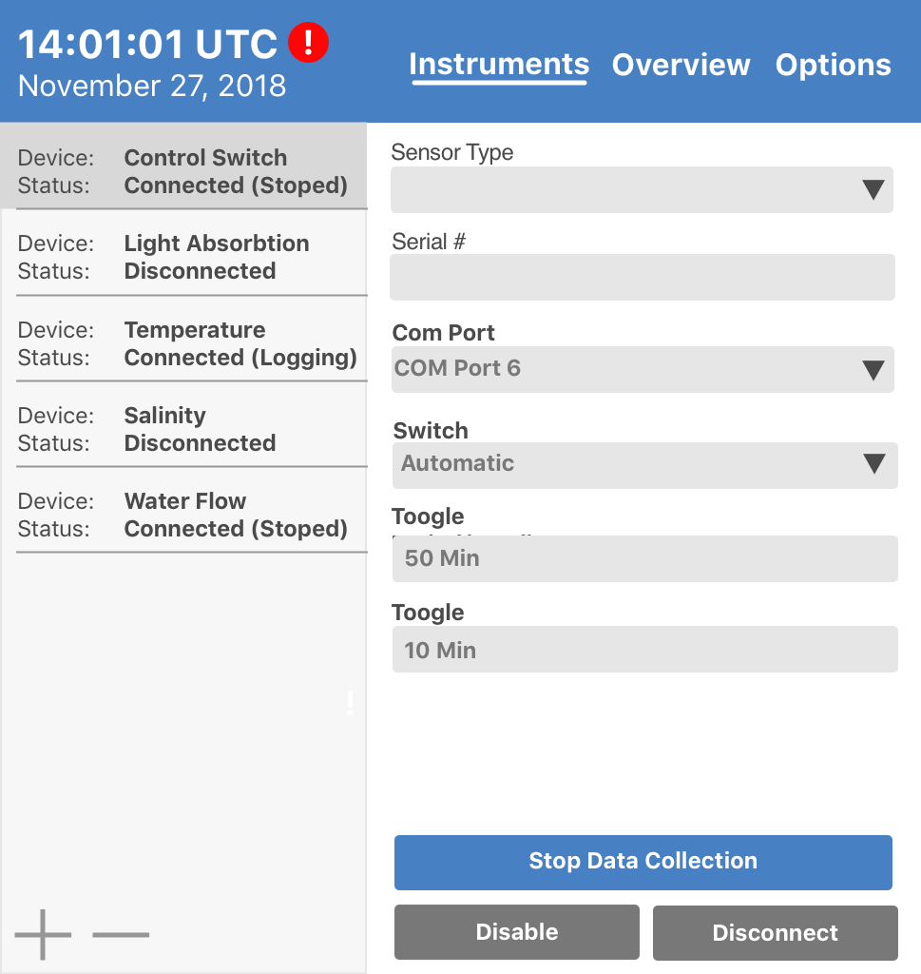

*Figure 2: the Settings Menu on the primary computer*

1. **User Interface Walkthrough**

Sections 3.1 and 3.2 will guide the user through the two different interfaces respectively: The Data Visualization User Interface that will be on the Secondary Computer, and the Data Collection User Interface that will be on the Primary Computer. The Data Visualization will be dedicated for monitoring and processing tool, while the Data Collection UI will be used as the logging control panel.

*3.1 Data Visualization User Interface Walkthrough*

**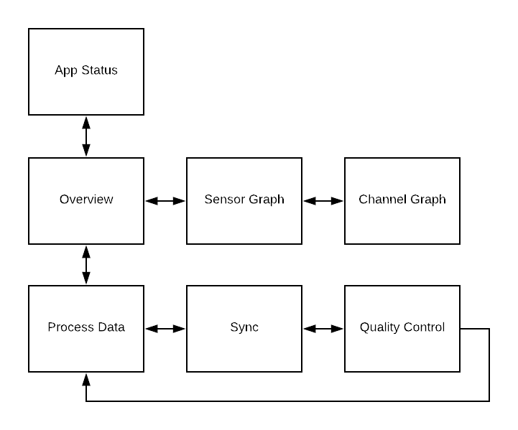***Figure 3: Navigation diagram for UI*

Figure 3 above shows how one page transitions to another page. In web system the user enter through the overview page. From here they will gain an overview of all of the instruments and the latest data being collected and the user has the option to process data, view a sensors graph, or access the application status. The primary case will be the user going to the sensors graph where the user can look at the data in more detail along with adjusting how the graph is displayed.

The secondary option will be for the user to process data, during this the user goes through a series of steps to select, sync, and trim the data through a graph view. In the third case the user can monitor the status of the application.

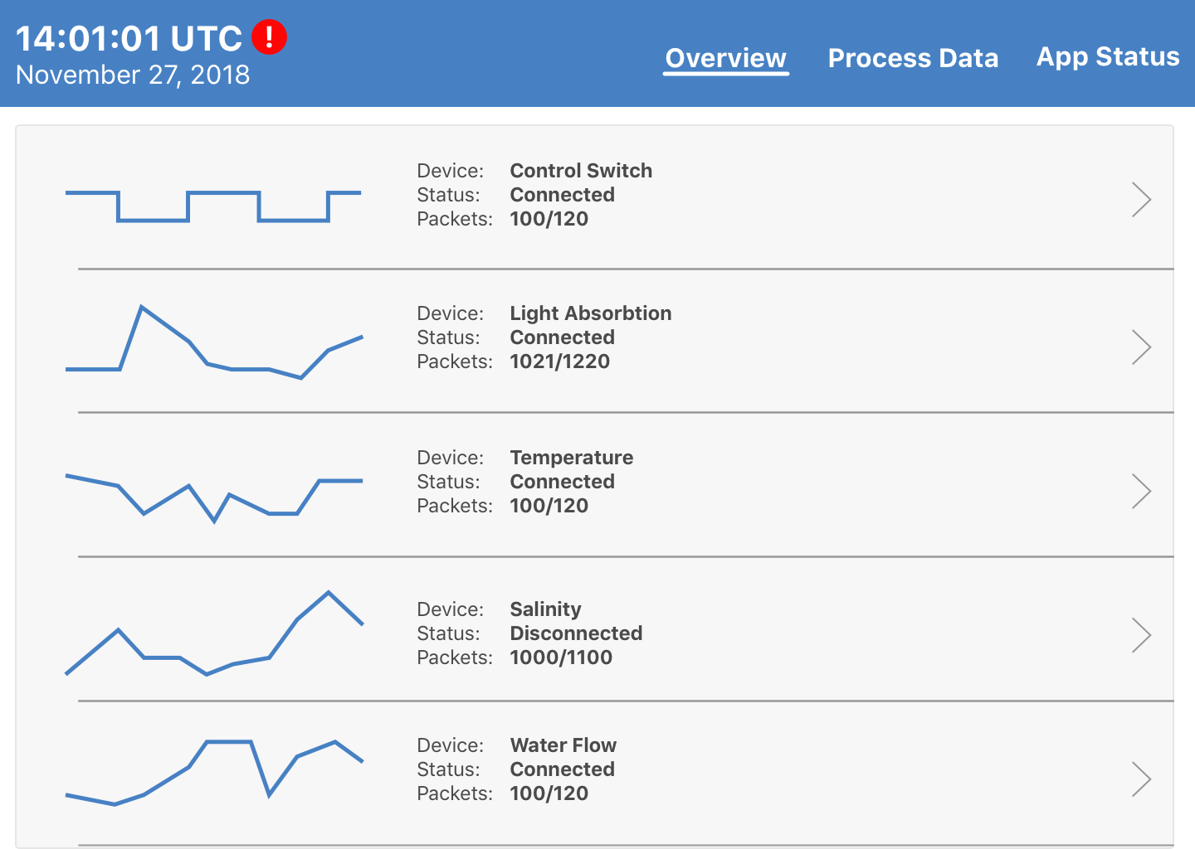

*Figure 4: The sensor selection screen*

Figure 4 shows the first page of the website contains a list of each sensor. Each sensor’s name, connection status, and packets, both incomplete and received, are displayed along with a graph of the raw data coming from the sensor. Clicking on a sensor will bring the user to the sensor’s window, while clicking process data will allow the user to edit and export recorded data. It’s also possible to navigate to the sensor page directly from the dropdown menu on Overview which will display a list of all the instruments (active and inactive).

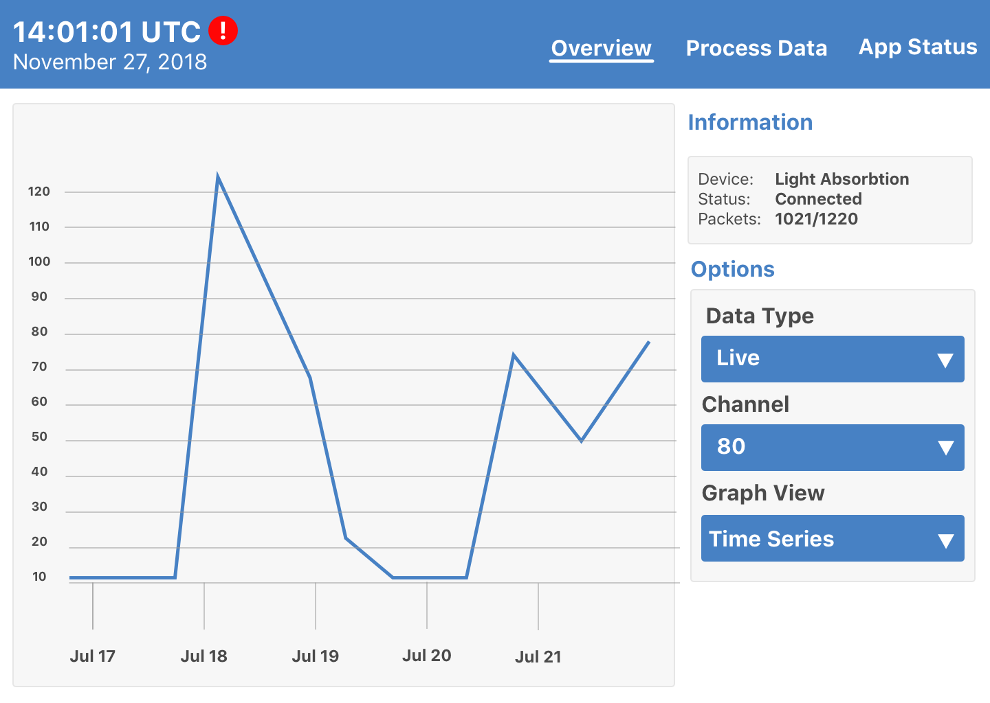  
*Figure 5: Data visualization for a sensor*

Figure 5 shows the sensor window. It contains a graph of the data a sensor has recorded. The user can view data collected over different periods of time or view a live graph of incoming panning and zooming on the interactive figure. The options for *Data Type* are *Live*, *Raw*, and *Processed*.

* *Live* data is the most recent data that is held within a buffer.
* *Raw* data is the unmodified data which won’t be changed. All data can be observed and as the benefit to not constantly update the figure which is troublesome when observing a given feature.
* *Processed* data is data that is processed with specific parameters.

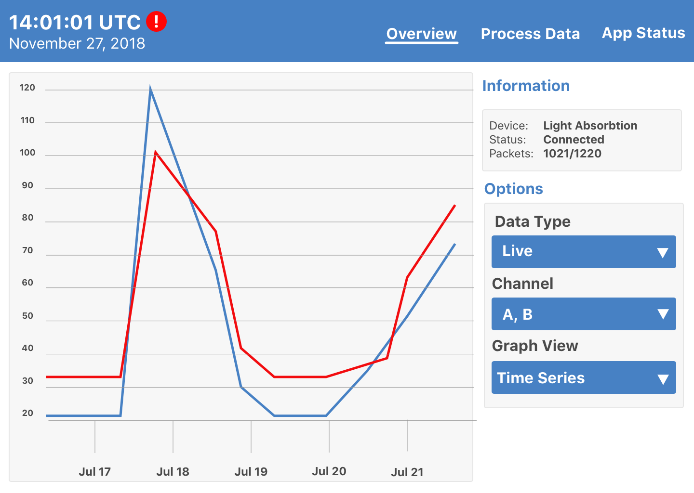

*Figure 6: Data visualization for multiple channels in a sensor*

In the same window (Figure 6), the user can select any number of a sensor’s channels to view using the *Channel* multiselect dropdown list. Each selected channel will appear on the sensor’s graph in a different color a legend indicates which color correspond to which channel. Channels of a same type will be displayed on the same y-axis (e.g. attenuation of light at 2 different wavelengths), channels of different type (e.g. temperature and salinity) will be displayed on different y-axis to scaling issues.

**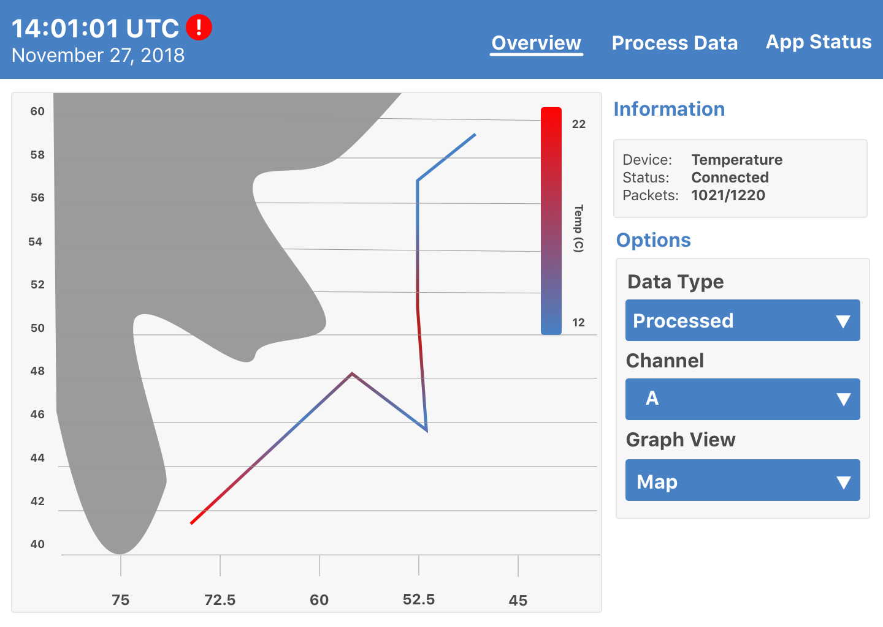***Figure 7: Map view of recorded data*

Users can use the *Graph View* (Figure 7) drop down list to swap between a time series graph and a map view graph. Map view will display a map of the area and show the ship’s path. A gradient is used to show the data recorded at a given point along the path. This map view can only be used for processed data. When multiple channels are selected, the latitude and longitude longitude of secondary channels will be shown slightly offset to prevent the graphs from being visualized on top of each other. The application will be flexible so that other graph view options can be integrated later on (e.g. 3D plots).

*****Figure 8: Viewing all of a sensor’s channels at once*

Figure 8 shows channels having multiple sub-channels (e.g. attenuation at ~80 wavelength). When the user clicks on a given time on the time series, the graph below will display the view of all the sub-channels. If multiple primary channels are selected in the time series, and they are associated with sub-channels, they willall be displayed in the plot below. In live view, the timeseries won’t be clickable, but the figure below will refresh automatically.

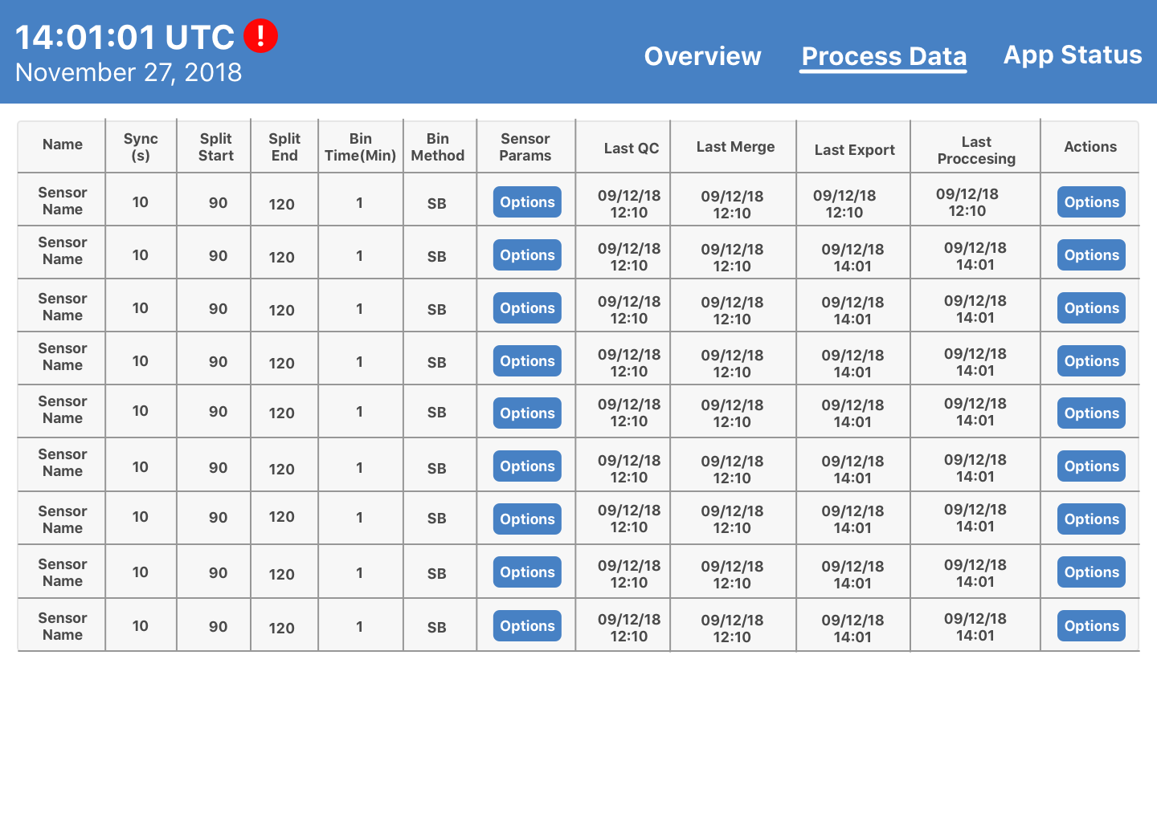

*Figure 9: Processing overview*

By selecting the *Process Data* tab located in the navigation bar will take the user to this screen (as shown on Figure 9). This page allows for the user to input parameters to process the data, some data such as bin time, bin method, split start, and split end will be modifiable on this page. When the user clicks on these items it will turn into a input box allowing the user to adjust these fields. The column instrument-specific parameters will show a pop-up box with parameters- specific to the processing of that instrument that can be edited by the user. Other fields such as Sync and QC redirect the user to dedicated graphic interface(as shown on Figure 10 and Figure 11). For each of the sensors there is an options button which allows the user to re-process, merge or export the data. While data is processing, merging or exporting a progress bar will be displayed in place of the time of the last operation.

**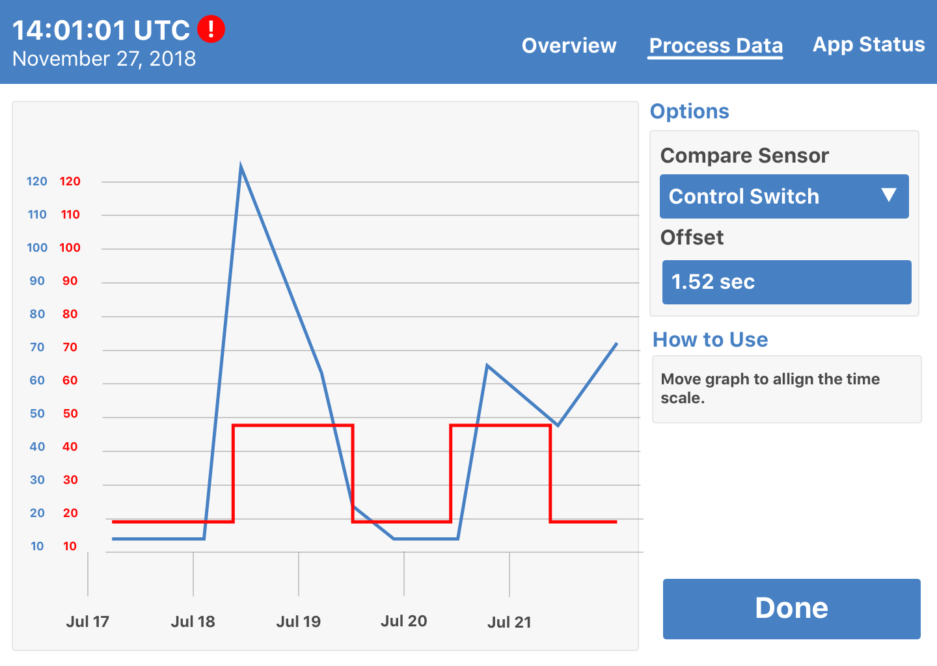***Figure 10: Syncing two sets of data*

Figure 10 shows the screen of different sensors have different delays between data being recorded and data being stored. the first step of processing data is for the user to remove this time difference. To do this, the user selects a point in the data they’re processing and matches it up with a corresponding point in data from another sensor,

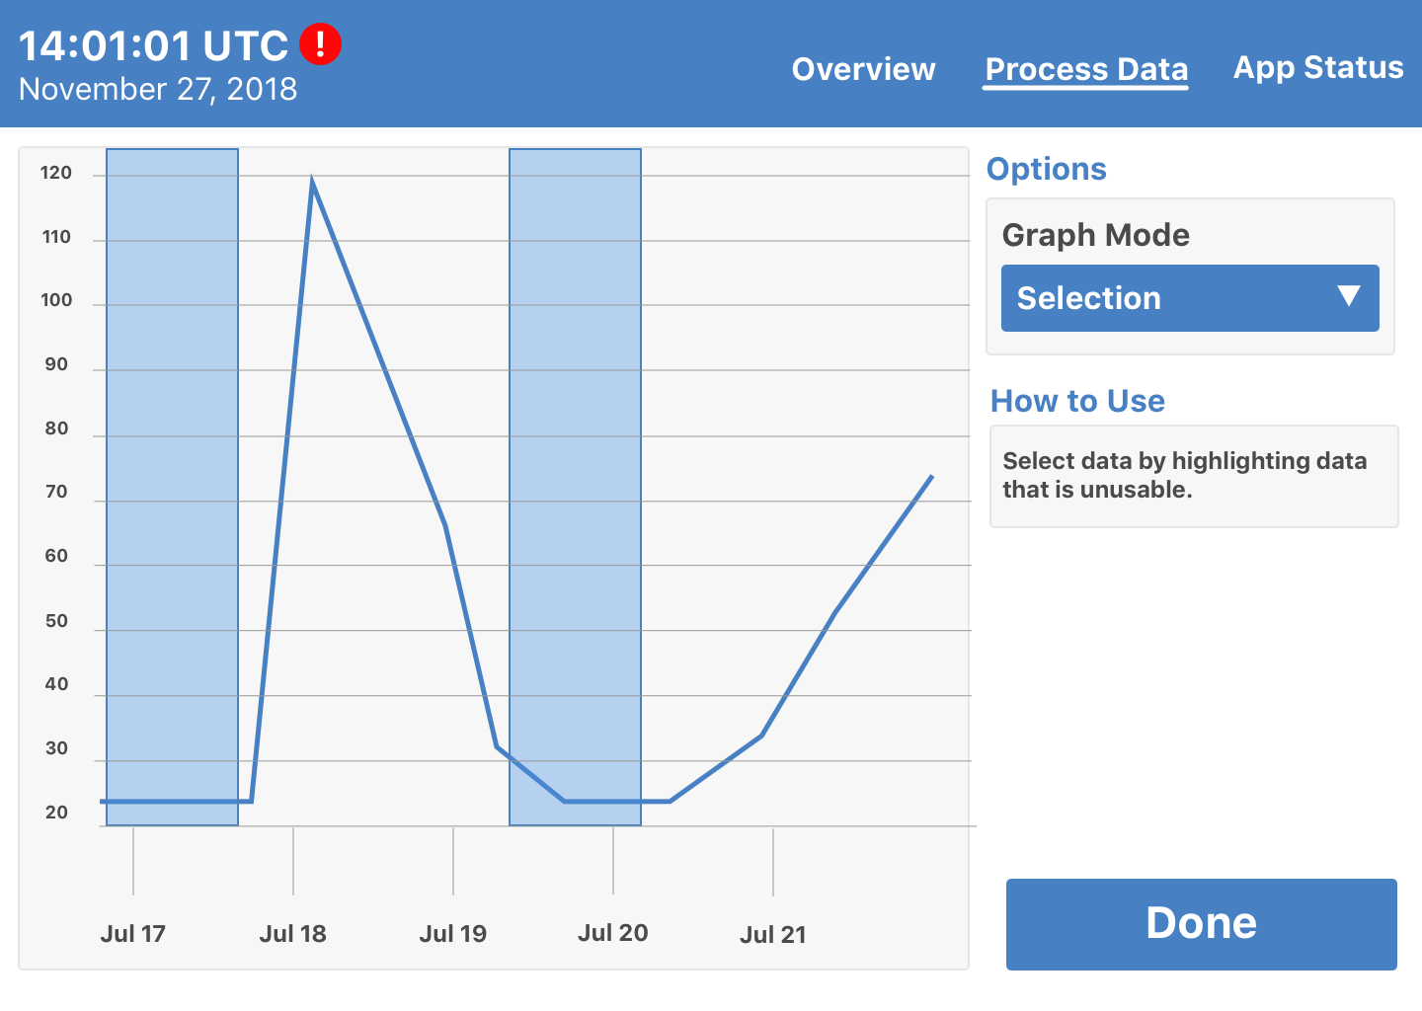

*Figure 11: Cutting out unusable data*

Figure 11 shows the screen for removing any unusable data. Users can remove data on this page by clicking the start of the unusable section followed by clicking the end of the unusable section. Any number of sections can be selected. Clicking inside the blue selected area will remove the selection. All selected areas will be automatically removed after clicking the *Done* button. The user will be able to zoom in the graph to examine smaller intervals. The screen will provide specific information of the graph, so when the graph is zoomed-in, the user won’t get confused, since the graph then may become significantly bigger, which can be easily mistaken as bad data. The *Graph Mode* allows the user to transition between three states: *Selection*, *Remove,* and *Navigation*. The *Selection* state allows the user to create blue areas of bad data, *Remove* allows the blue areas to be removed when clicking on a blue area, and *Navigation* state allows the user to zoom and pan over the graph. To switch between the states there will be keyboard shortcuts to allow the user to change the state quickly.

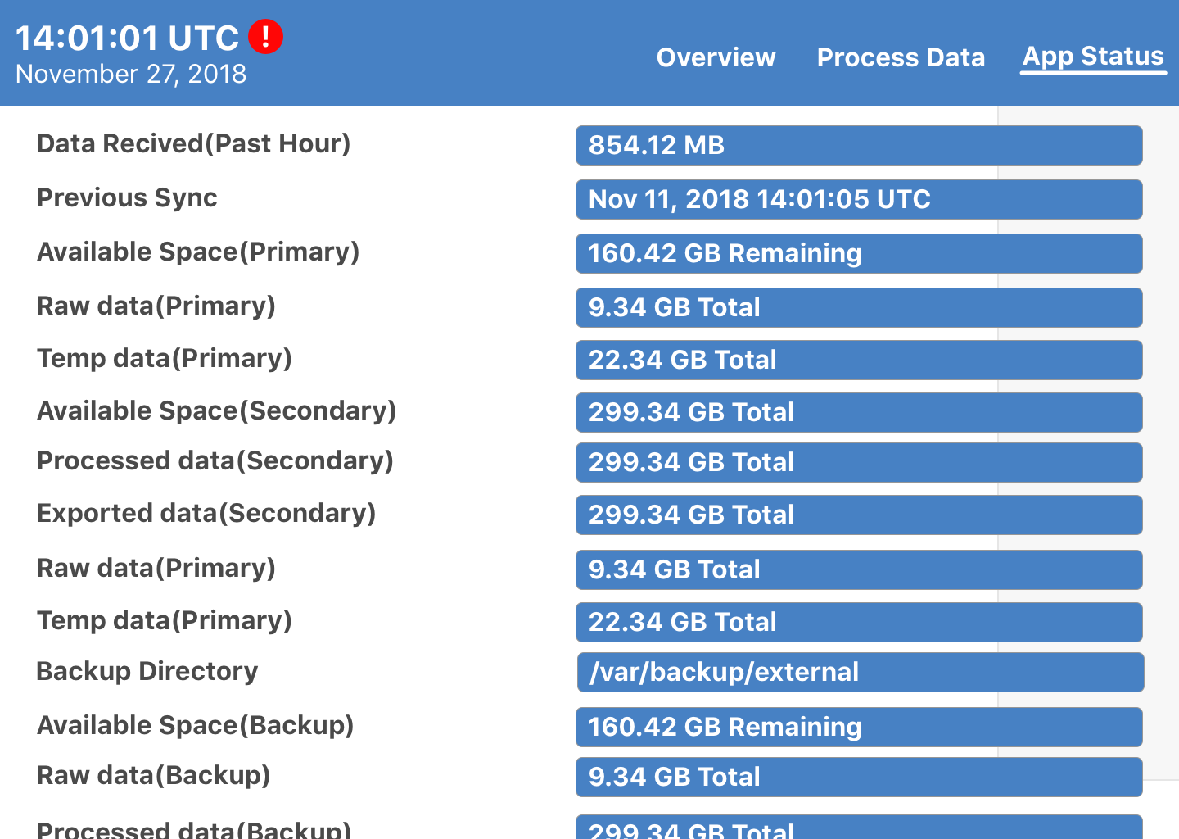

*Figure 12: Settings data visualization and backup*

Figure 12 shows the *Options* tab on the website. Here, the user can check where the data is backed up, space remaining in that location, amount of raw, temporary, processed and exported data in that location, and how much data has been received in the past hour.

*3.2 Data Collection User Interface Walkthrough*

  
*Figure 13: Setting up sensor inputs on the primary computer*

*Data Collection Settings* (Figure 13) is where the user can modify the sensors to affect the data collection process. The user can change the name, port, and how information is processed, as well as any settings unique to the sensor. Figure 13 above shows the unique settings for the *Control Switch*.The *Control Switch* has 3 extra options for the *Switch State*, the *Total Period* and the *Filtered Period*. A sensor can be in four state; *Disconnected*, *Connected*, *Disabled*, and *Logging*.

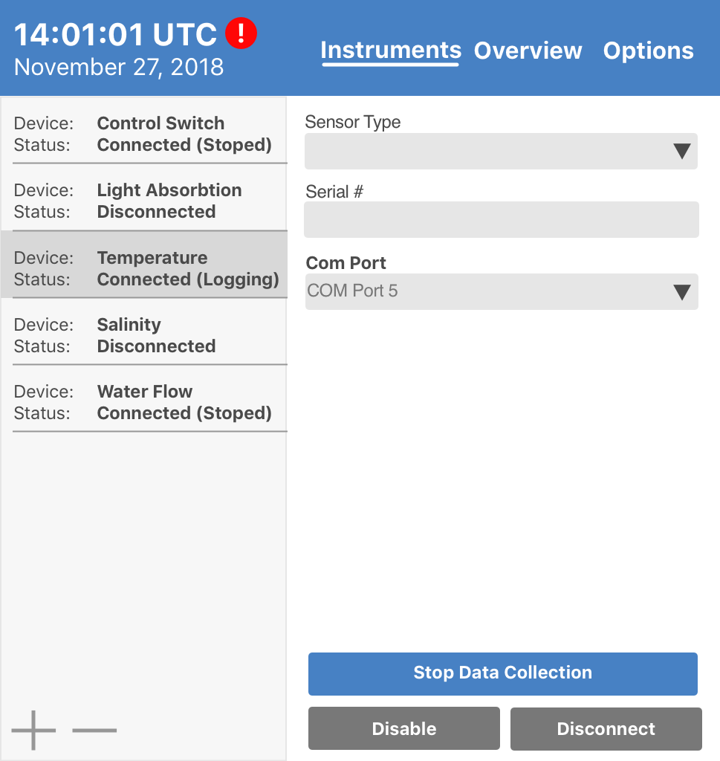

*Figure 14: More Settings for sensor inputs on the primary computer*

The usual device settings will be similar to Figure 14. The options for the sensors are *Sensor Serial Number*, *Sensor Type*, and *Port*.

In addition, there are 3 options for all devices (including the Control Switch):

* *Stop Data Collection*: to stop the data collecting process of a specific Device.
* *Remove*: to remove a specific Device
* *Disconnect*: cease the connection of the chosen device, without removing it from the current system.

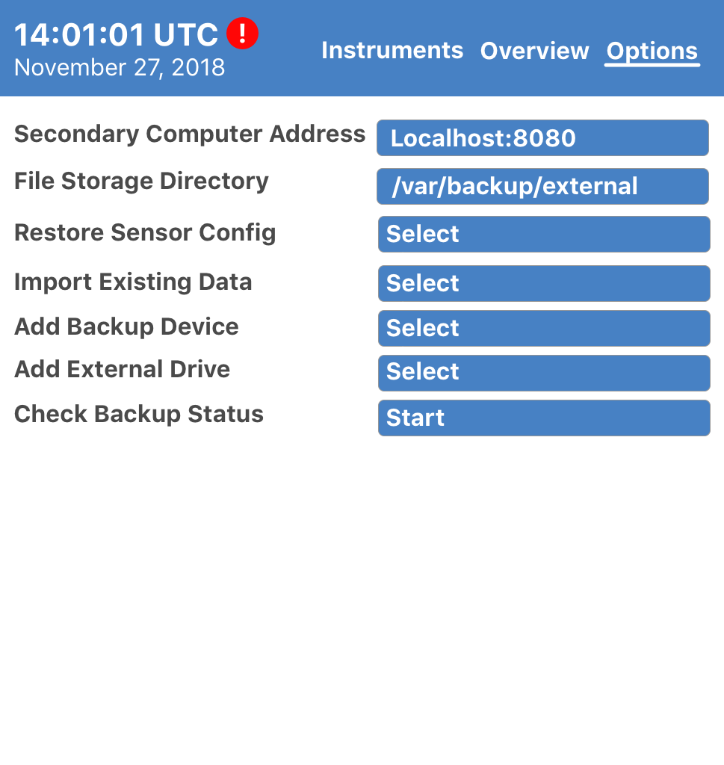

*Figure 15: System Settings for Data Collection*

Figure 15 shows the *Options* tab for the primary computer. Here, users can check the IP address of the secondary computer that gets passed the raw data, where data is backed up to, import a config file for a sensor, or import previously recorded data.

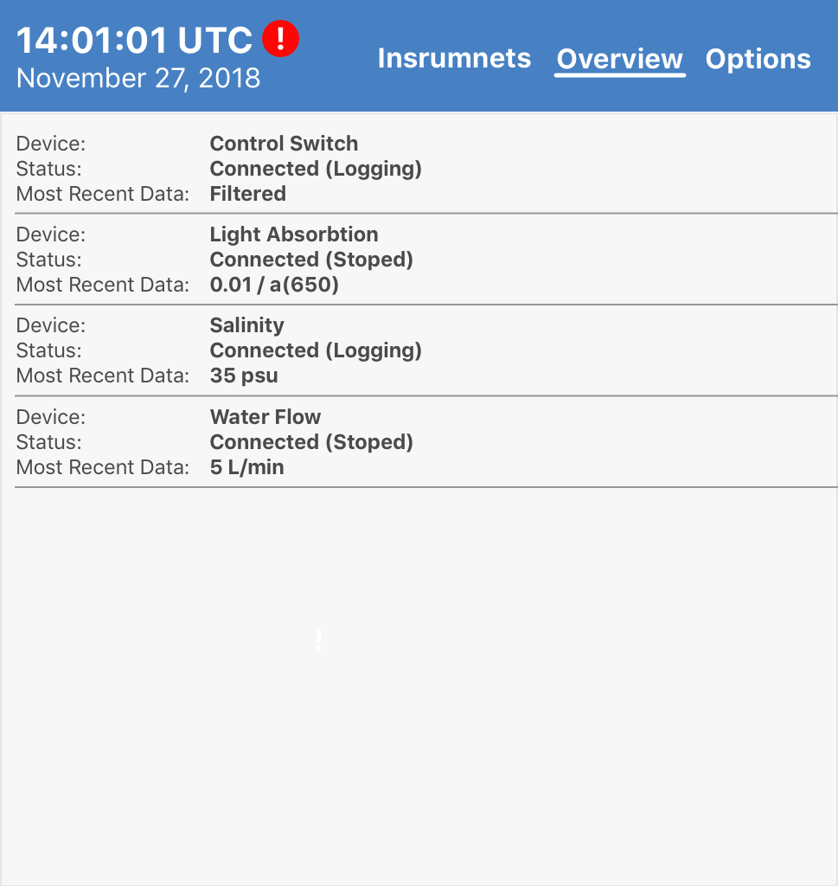

*Figure 16: System Overview*

Figure 16 Shows an overview of the system with the current data printed out in the *Most Recent Data*. This allows the user to view the each of the sensors status and if data is being collected.

1. **Data Validation**

The data being entering the system by a user is for the setup of the system and processing of the data. This data consists of name, port, and protocol. Name has no functional purpose only affects file names and visualization, port is a drop down which means these fields have limited options, and protocol is in an editable config file that can be changed if config is inaccurate. All of the other data coming into the system is from the sensors and is handled by the system.The system also has tools while processing data to make up for differences in time taken to record data and to delete unusable data. See Table 1. for break down of data points and data type.

The user input during the processing phase will not override the original data so if a mistake or error occurs during the processing phase the raw data can be processed again.

|  |  |  |
| --- | --- | --- |
| **Data Point** | **Data Input** | **Data Method** |
| Serial Number | String | Text Box |
| Sensor Type | String | Drop Down |
| Port | Int | Drop Down |
| Protocol | String | Config File |
| Sync | Float | Graph View |
| Quality Control | Array of Floats | Graph View |
| Bin | Integer | Text Box |
| Bin Method | String | Drop Down |

*Table 1. Data input method*

**Appendix A – Agreement Between Customer and Contractor**

This document is an agreement between the Customer (Nils Haëntjens) and Contractor (Team Aqua) stating the requirements that will be included in the system. For the system to accepted all functional requirements must be completed and pass the test documented. By signing this both the Customer and Contractor agree on the work that must be completed and handed over to the Customer (Nils Haëntjens) before the deadline of December 19, 2018.

If changes of the system or requirements are requested from either the Customer or Contractor this document will be updated stating the changes requested and the reasoning behind the changes. For the requested changes to go into effect the document will need to be signed by the entirety of the team and the customer. From that point on the most recent System Requirements Specification will be the document referred to in future documentation.

Team Signatures:

Jacob Hall _____________________________ Date: _______________

Samuel Segee _____________________________ Date: _______________

Chi Anh Nguyen _____________________________ Date: _______________

Customer Signatures:

Nils Haëntjens _____________________________ Date: _______________

Customer Comments:

**Appendix B – Team Review Sign-off**

By signing my name below, I certify that I have read, reviewed, and agreed to the information and requirements stated in this document.

Contractor Signatures:

Jacob Hall ____________________________ Date: ________________

Comments:

Samuel Segee _____________________________ Date: ________________

Comments:

Chi Anh Nguyen _____________________________ Date: ________________

Comments:

Customer Signatures:

Nils Haëntjens _____________________________ Date: ________________

Customer Comments:

**Appendix C – Document Contributions**

**Sam Segee:** Sam Wrote the first drafts for the written parts of Section 2, most of section 3 and half of section 4. Overall, Sam wrote about 25% of the document.

**Jacob Hall:** Jacob did all of the figures and graphics for the document. He also help with the data validation section and editing the UI Walkthrough. Overall, Jacob contributed 50% to the final document.

**Chi A. Nguyen:** Chi wrote the purpose of the document, contributed in editing the UI Standards, helped designing and revising the figures in the UI Walkthrough, and their description. Overall, Chi contributed 25% of the final document.

**Appendix D – Version Control**

|  |  |
| --- | --- |
| **Version** | **Date** |
| Version 1 | November 29, 2018 |
| Version 2 | November 30, 2018 |
| Version 3 | November 30, 2018 |
| Version 4 | November 30, 2018 |